Assignment 4
  - PUBH 7462 - Assignment 4
Patrick Torralba

Introduction

Question
How does the amount of time spent sleeping per day vary by age group?

Methods
I created a table to show the mean, median, and standard deviation of the number of hours spent on sleeping for different age groups.
And, I also created a simple bar graph that shows the average sleeping hours by age group.

Results
Table 1: Daily Sleep Summary
Age Group (Years) | Average | Median | SD
1-17 | 10.0 | 9.8 | 2.3
18-24 | 9.5 | 9.5 | 2.5
25-39 | 8.8 | 8.7 | 2.2
40-59 | 8.7 | 8.5 | 2.3
60-79 | 8.9 | 8.8 | 2.2
80-100 | 9.3 | 9.0 | 2.1

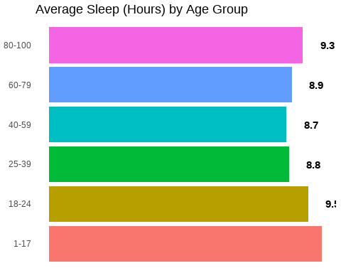
Figure 1: Average Sleep (Hours) by Age Group
The group with the highest and lowest daily sleep hours are 1-17 year olds and 40-59 year olds, respectively. Figure 1
The median didn’t vary too far from the mean, and the standard deviation for all groups is between 2.1-2.5 hours. Table 1

Discussion
- 1-17 year age-group has the highest average daily sleep hours
- 40-59 year age-group has the lowest average daily sleep hours
- Average and median values are roughly similar
 Important
There are some limitations to this analysis. For example, babies and infants were grouped in the 1-17 age-group. This is a limitation because since babies and infants sleep more often than older children and adolescents, they can skew the average. Another limitation is that statistical significance was not tested. Therefore, it is unknown if the average sleeping hours by age-group is actually meaningful.

